Title (Font Size 18, Times New Roman, Capital-Small)

Introduction of Research Scholar Introduction of Supervisor

Name: Roll No:
Class:

Name: Designation:
Department:

Session:
Institute:

School of Faculty of
MINHAJ UNIVERSITY LAHORE HAMDARD CHOWK TOWNSHIP LAHORE

Research Proposal Form

Program: M. Phil: Session Subject: Name of Student: Roll No:
Father’s Name:

The Title of the Research

1. The title should be concise, well worded and grammatically correct.

2. It should be innovative and original.

3. It should also be aligned with the research questions/objectives of the study.

Introduction

1. It should provide a brief description to introduce the area of the proposed research work and background of the study.
2. The introduction must be relevant to the research topic and must not discuss the general knowledge and information about the subject.
3. It should introduce the research topic and should be in paragraphs.

4. Each paragraph should be of reasonable size. A paragraph should neither be of full-page nor be of a long paragraph. (A good paragraph is of 6 to 7 lines)
5. The size of the introduction of M. Phil research proposal should be 1, and a half page long minimum with some references. In case of PhD, the introduction can be of 5 pages length maximum.

Objectives

1. Objectives must reflect and be aligned with the primary aim(s) of the research topic.
2. Objectives must also be measurable and be written in the protocol of the research methodology.
Socioeconomic / Rationale / Practical & Scientific Applications

1. Contribution to the literature should be obvious.

2. Socioeconomic, theoretical and practical benefits/outcomes should also be visible.
3. For research proposals related to the Science programs shall discuss the Scientific

Applications and not the Socioeconomic aspects.

Hypothesis/Research Questions

• Hypothesis

1. Hypothesis is only required in case of quantitative research. In case of qualitative studies, describing the research questions is sufficient.
2. Given hypothesis should be testable, and not be written general rather as null hypothesis.
Example

H01: There is no significant difference between _ (the control and experimental groups on the independent variable) on (dependent variable).

• Research Questions

1. Research questions should be written as per the research standards and be aligned with the research objectives, and research methodology of the study.
2. Research questions should be precise and self explanatory.

Review of the Literature

1. Previous research works and studies related to the study under subject should be reviewed to the maximum and upto the recent available studies. Previous research works include published PhD thesis, Master/M.Phil thesis, research papers and books.
2. Previous research works to be reviewed, could be theory based/applied models or concept based.
3. It should end in a critique that illustrates the gaps in the research and not just summaries of books/articles.
4. For the proposal of M. Phil thesis, minimum number of references should be ten, and for the proposal of PhD thesis, the minimum number of references should be
25 but the most relevant to the study.

Research Gap

1. Research gaps should be highlighted and critically appraised after the review of the literature under this section.
Research Design and Methodology

1. A comprehensive and detailed description of the research methodology for the study should be provided. This section should clearly state whether this study is a Qualitative, Quantitative or Mixed Methods Research.

2. For the proposal of M. Phil thesis, research methodology section should be one to two pages long minimum and for the proposal of PhD thesis, research methodology section should be minimum five pages long however the longer, the better.
3. Research methodology section should provide enough information about the data collection, sources of the data, data type (primary or secondary), population, sample size (for example population size or number of cities etc.), sampling technique, variables (dependent and independent variables) to be used, questionnaire, estimation techniques and software etc.
4. In research methodology section, candidate should also provide the rationale for specific sample size selection and the sources selected for data collection. For example, in case of Economic research why the candidate has selected so and so country and not the other and why the candidate has retrieved the secondary data from World Bank Database and not from some other databases.
5. This section should provide the details that how the research objectives will be achieved; or in case of hypothesis, how it will be tested.
6. If a part of the study involves some survey through questionnaire, the questionnaires to be used should be annexed with the proposal. If the questionnaire is adopted from any previous study, proper reference should be given. If candidate has developed a new questionnaire for the study, information related to the reliability check and validity, rationale for selecting specific variables and types of questions, should be provided.

Delimitations and Limitations

1. In this section, a candidate should write about delimilations of the study.

Researcher should also clearly mention the limitations he/she can face while collecting data and doing survey. For example, non availability of the data for some specific years, expected difficulty while getting the questionnaires filled, non availability of relevant previous studies, or non availability of resources.

Proposed Chapters for Thesis

Chapter No.1 Introduction

Chapter No.2 Historical Context/Theoreticl Framework

Chapter No.3 Review of the Literature

Review of the literature could be expanded two chapters if deemed necessary

Chapter No.4 Research Design and Methodology

Chapter No.5 Results and Disucssions

Chapter No.6 Conclusion and Policy Implications

Last Section References/Bibliography

References/Bibliography

List all resources that are cited in your research work. References and Bibliography should be written according to APA Manual 6th Edition. Examples for Writings
Referencing Journals Articles

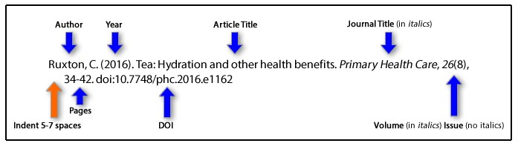

In text citation: Ruxton (2016)

Journal Article with DOl

Herbst-Damm, K. L., & Kuhk, J. A. (2005). Volunteer support marital status, and

the survival times of terminally ill patients. Health Psychology, 24, 225-229. doi:

10.1037/0278- 6133.24.2.225

In text citation: Herbst-Damm and Kuhk (2005)

Journal Article without DOl

Labbo, L. D., Place, K., & Soares, L. (2010). Fresh perspectives on new literacies and technology integration. Voices From the Middle, 17(3), 9-18. Retrieved from http://www.ncte.org/journals/vm/
In text citation: when signal phrase Labbo, Place and Soares (2010) and when at the end of the sentence (Labbo, Place & Soares, 2010).

Online Publication Where No Author is Included

American Association of Community Colleges. (2009). About community colleges.

Retrieved from http://www.aacc.nche.edu/Pages/default.aspx

In text citation: American Association of Community Colleges (2009)

Referencing a book

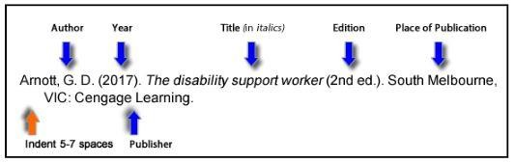

In text citation: Arnott (2017)

Referencing Newspaper Articles

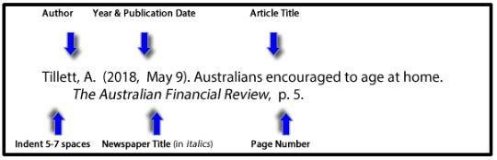

In text citation: Tillett (2018)

Referencing Material from the World Wide Web

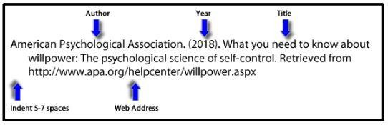

In text citation: American Psychological Association (2018)

Referencing conference proceedings

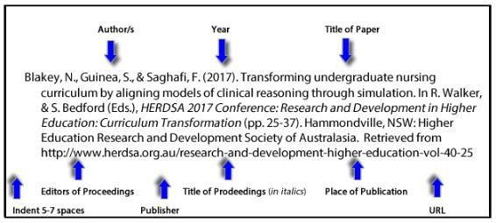

In text citation: Bilakey, Guinea and Saghafi (2017)

More Examples of In-text Citations

Here is an example of a citation used when the author(s) are noted in the text: Hawley and Harris (2006), for example, found that students who believed they could face challenges were better able to strategically anticipate and plan how to incorporate 2 challenges into their academic schedule, resulting in greater levels of success. Here is an example of a citation used when multiple references are included in a single citation (Gloria & Ho, 2003; Rayle, Robinson-Kurpius, & Arredondo, 2006; Rosenthal, 1995). Note that the citations are listed alphabetically. Here is an example of a citation for multiple references in a single citation all by the same author (Pervin, 1968, 1989, 2001).
Here is an example of a citation used when a references has more than six authors (Nicpon et al., 2007). In this case, “et al” is used in place of listing all authors. Here is an example of a citation for a quote; note that “the quote is provided and then the reference includes a page number” (De Raad & Perugini, 2002, p. 29).

--------------------------------------------- Name:
Research Scholar

Report of the Supervisor

-------------------------------------------------------------------------------------------------------

-------------------------------------------------------------------------------------------------------

-------------------------------------------------------------------------------------------------------

Supervisor Head, School of

Work Plan

3rd Semester (16 Weeks)

04 weeks | Literature Review | Comments by Supervisor
02 weeks | Methodology | Do
08 weeks | Data Collection | Do
02 weeks | Data Analysis | Do

4th Semester (16 weeks)

10 weeks | First Draft | Comments by Supervisor
03 weeks | Second Draft | Do
02 weeks | Final Draft | Do
01 weeks | Submission of Thesis | Do

IMPORTANT GUIDELINES

Format your synopsis according to APA Manual 6th Edition.

Paper Size

A4 size be used, no restriction is placed on drawings and maps.

Font, Size and Spacing

Use Times New Roman font, text size 12 with double line spacing.

Indention

Write each paragraph with indention

No. of Copies for Mentor and BOAS&R

Four copies for mentor 11 for BOAS&R on good quality paper (minimum 80 grams) should be submitted.
Table 1

Format of Headings

Level | Format
1 | First Level Heading is Centered, Bolded and First Letter of Words  Capitalized  Text begins as a new paragraph.
2 | Second Level Headings are Bolded, Flush Left and Beginning of Words  Capitalized  Text begins as a new paragraph.

3 Third level headings are bolded, indented and only the first word is

capitalized. Note that third level headings end with a period.

Note: For information on fourth level headings and beyond, please see the APA 6th edition Publication Manual.

Margins

All sections of the manuscript should have a 1.5-inch margin on the left side and a one-inch margin on the top, bottom and right sides. All text will only be left justified. Page Numbering
Page numbering starts with a “1” from Introduction page.

Note

1. For other information like format of table and figure etc., please see the APA Manual 6th edition.
2. Research proposal and thesis should follow APA 6th for In-text citation,

references and formatting. Other referencing styles are not acceptable.

3. Studies done in Urdu language related to the Departments of Urdu, Arabic,

Islamic Studies should follow the University’s prescribed reference style.

